Lab 5
Student: Toleubek Assiya
Data storage and analysis

Lab Tasks: A/B Testing Analysis
Your goal is to analyze whether the new website design (Treatment B) performs better than the old design (Control A). Follow the steps below.

1. Formulate Hypotheses for Each Metric
Write null and alternative hypotheses for:
- Conversion rate (proportion of visitors who purchase)
H0: p_B ≤ p_A (no improvement)
H1: p_B > p_A (one-tailed test, since we only care whether version B performs better)

- Time on site (average seconds spent)
H0: μ_B ≤ μ_A (no improvement in average time spent)
H1: μ_B > μ_A (one-tailed test, since we only care whether version B increases time on site)

- Pages viewed (average number of pages)
H0: μ_B ≤ μ_A (no improvement in average pages viewed)
H1: μ_B > μ_A (one-tailed test, since we only care whether version B increases engagement)

2. Check Assumptions
For each metric, verify the necessary conditions for the chosen test:
- Conversion rate (two-proportion z-test):
  - Independent observations (random assignment)

Users were randomly assigned to groups A and B, ensuring independent observations

  - Sample size large enough (expected successes/failures ≥ 10 in each group)


Both expected successes and failures are greater than 10, satisfying the sample size requirement for the two-proportion z-test

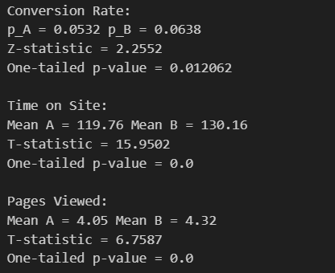

Treatment B improves purchase rate (the rate increased from 5.32% to 6.38%);
B keeps users engaged longer (119.76 vs 130.16);
B encourages users to browse more pages(4.32 vs 4.05).
All three metrics are statistically significant
so Treatment B outperforms Control A in conversion, engagement, and browsing behavior.

